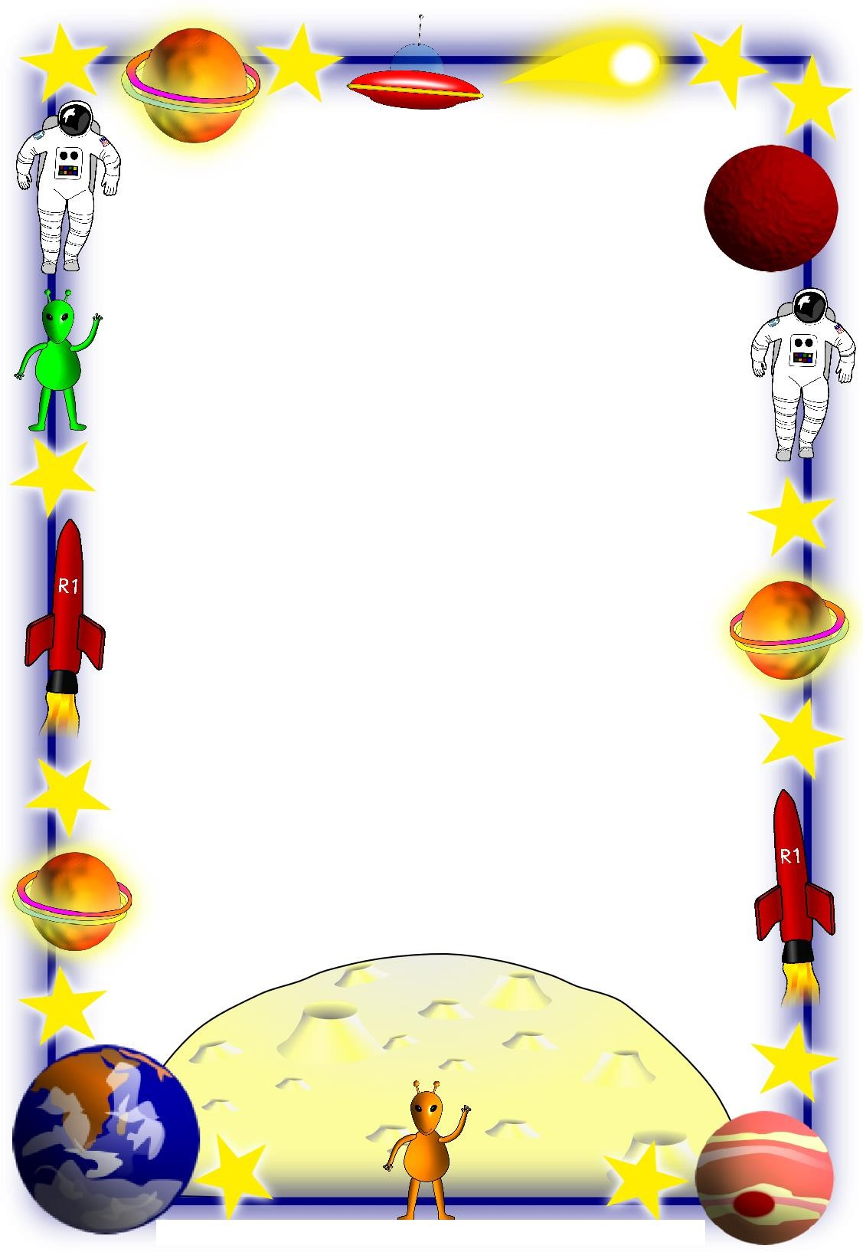

Over the next term, Year 5 foundation homework will be to create a topic project all about Space. To promote taking responsibility for your own learning as you get older, this homework is designed to give a greater choice and to allow you to complete work that interests you personally. We have given a list of suggested tasks associated with Space.

To complete this project, you will need to complete 4 tasks from a range of curriculum areas. You will have approximately 2-3 weeks for each piece of work, so we do expect for it to be detailed and well presented. You are allowed to complete the tasks in any way that interests you and if you have any fantastic ideas that are not on the list, please ask your teacher so that they can advise you!

The work must be handed in on the following dates:

- Friday 20th September 2019
- Friday 4th October 2019
- Friday 18th October 2019
 Friday 8th November 2019

- Draw or paint a picture of something Space related (Art).
- Create a poster showing the names and relative sizes of the planets in the solar system (Science).
- Create a poster about the pros and cons of training to be an astronaut (English).
- Write a diary entry as an astronaut in space (English).
- Create a cartoon strip about Doctor Who discovering a new planet (English and Art).
- Create a fact file about a famous Space Shuttle (History).
- Design a job advert for an astronaut (English).
- Write a radio speech about an astronomical event (i.e. meteor shower, moon landing, shuttle launch etc.)
- Write a poem about the beauty of Space (English).
- Create a fact file about a famous astronomer or scientist (History and English).
- Imagine you are an astronaut. Write a letter home to your family (English).
- Collect data on the amount of money spent on Space travel by different countries and present the data in a chart of your choice (e.g. bar graph/pie chart) (Maths)
- Make a PowerPoint presentation about The Solar System (Computing).
- Design a detailed excel document of the items that you would need for a trip into space, including quantities and cost (Computing).
- Read a space related book (suitable for children) and then write a review (English).
- With permission, watch a space related movie and write a film review (Media).
- Create an information page about a country’s Space Program and history of exploration (History).
- Write a scene of a play set in Space and act it out (Drama).
- Create a 3D model of the solar system (DT).
- Carry out a science investigation to record the sun rise and sun set times for 2 weeks. Draw a graph to show this (Science).
- Create and record a TV program, teaching people facts about the solar system (English and Computing).
- Write a story about living in Space or on another planet (English).

